04.03 Training and Qualifications
Process Design & AMOS Configuration Document
Purpose
This Process Design document is provided to Key-Users to record their key decisions regarding the AMOS Process design and the required AMOS configuration.
It is updated throughout the Project Definition Phase and used as the baseline for the Final Acceptance prior to Go-Live
Revision
Author, Name | Date | Notes
Jakub Sadowski | 01.12.2024 | Edition 24.12 – including diagram corrections

Table of Contents
1. Process Overview & Objectives 3
Staff records allowing appropriate: 3
• Capacity Planning 3
• Staff Training Planning 3
• Authorization Control 3
2. Definitions & Glossary 3
3. Process Tasks 3
4. Process Dependencies 4
5. Process Flow 5
6. Process Design Questions 6
7. Data Source Mapping 7
8. Other Software Used 7
9. AMOS Configuration 8
a. Process specific configuration programmes 8
b. Basic Data 8
c. Parameters 9
d. Workflows 9
e. Scheduled Tasks 10
f. API’s & Interfaces 11
10. UAT Guidance 11
11. Annex – Additional Info 11

Process Overview & Objectives
Process General Description:
Setup of Qualifications System and manage the assignment, update, expiration and renewal of Qualifications and/or Technical Licenses.
Prepare company-wide Staff Training Courses and Training Schedule. Assign Staff to Courses, Control Results and Update Qualifications.
Main Process Objective (Outputs & Outcomes):

Staff records allowing appropriate:

Capacity Planning

Staff Training Planning

Authorization Control

Definitions & Glossary
Key-Words | Explanation
Event Classes | The Event Class in AMOS defines e.g. AMOS Course, Mechanic License, Company Authorizations, Driving Licenses, Tool Licenses etc.
Event Types | The Event Type in AMOS defines e.g. an AMOS Introduction Course, Mechanic License like EASA Cat. A, B, C, or any internal defined category like Medical Checks.
Event Type Fields | The event type fields serve to assign so-called Identifiers to an Event Class. Meaning the Identifiers of the AMOS Course or Mechanic License, so e.g. Base Maintenance License Aircraft Engineer (B1 and B2).
Event Fields | The Event Fields service to assign the individual criteria that the license has for each employee. E.g. this can be A/C type ratings, expiry date, start date/end date, etc.
Signoff Setting | AMOS allows to be configured in a way that certain criteria have to be met to allow the user to Signoff a document. E.g. the document skills can be checked against his/her Qualifications. Also there can be defined security levels per Signoff: Identification is enough or re-entering of the password required?

Process Tasks

Prepare Course – Use APNs 551 and 704 to define courses
Participate in Course – Staff is able to self-register for courses/exams in APN 2253
Assign / Update Staff Qualification – depending on Company’s policy either all staff’s or only technical staff’s qualification might be managed in AMOS, avoid duplication if other system is predominantly used for other qualifications (e.g. Q-Pulse)
Monitor Qualification Expirations – use APN 146 to monitor expiring qualifications or set appropriate scheduler task to generate automatic e-mails
Define / Enrol Staff to Courses – if the staff is not self-enrolling, it can be doe by course manager in APN 551
Print Staff Authorisation Sheets – APN 146 allows creation of Authorisation Sheets for the staff

Process Dependencies
INPUT | CONCURRENT | OUTPUT
- 00.01 Application Configuration  - 00.02 Users & Roles  - 04.01 Company Organization  - 07.02 Hangar and Resources | 00.04 Scheduler Tasks | 07.02 Hangar and Resources

Process Flow
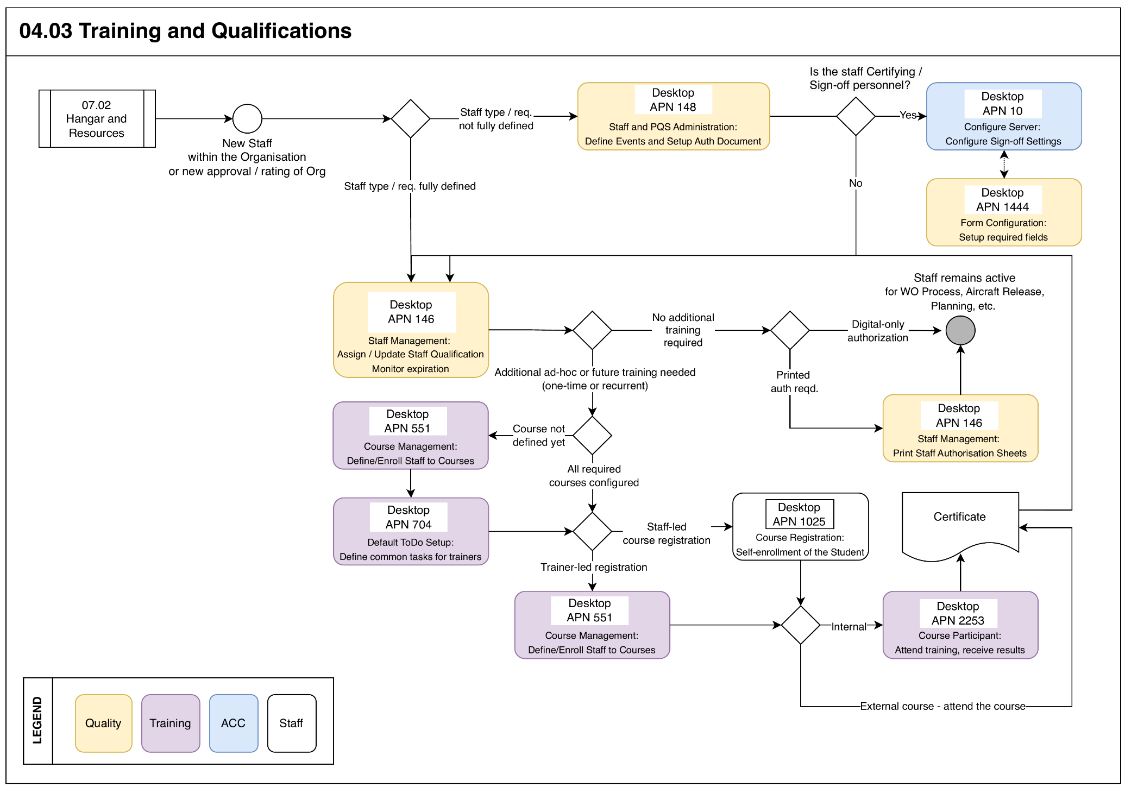

Process Design Questions
# | Question | Answer
 | Does AMOS control the users’ qualifications?
 | Do you want AMOS to check the user’s Qualifications during Signoff? Check Signoff Setting in Configure Server (APN: 10)
 | Do you want to implement/manage Staff Training in AMOS? If Yes, Training Qualifications have to be defined.
 | Do you want to implement Shift planning in AMOS?

Data Source Mapping
Data Sources | Description | Volume / Manual / Automatic / Static / Dynamic
-/- | -/- | -/-

Other Software Used
Other Software | Used by: | Description
-/- | -/- | -/-

AMOS Configuration

Process specific configuration programmes
AMOS APN | Notes
APN: 14 Admin Logins | Define the user logins and assign them to user roles.
APN: 15 Admin Roles | Define user roles and assign access rights (licenses) to each of them.
APN: 146 Staff Management | Define employee data.
APN: 148 Staff and PQS configuration | Define Qualification Classes and Authorisation Documents
APN: 1444 Form Configuration | Adjust visilibity / mandatory fields in forms. Customize the fields of the Qualifications when they are assigned to an employee. It is possible of customize these fields differently per Event Class.

Basic Data
Basic Data Table | Notes
Planning Qualifications | Needed in order to request a Qualification as a Resource, or for an assignment of a Skill or a Scope to an Employee.
Type of Work | This Basic Data is associated with the Scopes defined in the Planning Qualification Basic Table.  The main reason for usage is commercial. The data is used for: Conditions, Time Framework, Quotation Generator an Billing.
Course Language | The language that a course could be taught in.  For example ENG for English or SGR for Swiss-German.
Course Type | Defines the "course type" codes used for simulator course manager.
Exam Type | Type of exam.  For example MC for multiple choice or ES for essay.
Instruction Type | Type of the lesson.  For example FRO for frontal or PRA for praxis.
Overwrite Reasons | Specifies the Reasons a Course Manager can overwrite existing exam results. The code will be saved in the exam-result Database.  The entries here are available in the Edit-Exam-Result Dialog of APN551 "Course Management" if the User has the License "Overwrite Exam Results".  The User then needs to choose one of the Reasons specified in this Table.

Parameters
Parameter Code | Parameter Name | Notes
978 | URL to the PQS-Personal Pictures. | Provide URL to PQS-personal pictures if you want to use Staff Pictures e.g. for the personal Qualification Document.
1120 | Path to SAP Transfer file. Only if SAP is the Staff Admin master system. | This parameter is only used by customers for data import from SAP to AMOS
1149 | PQS Event Class for Part Capability | This Parameter tells the application Staff Management which Qualification Class in Staff&PQS Configuration represents a Part Capability.
1240 | Internal Capability (related to CM) | This parameter defines the interval which will be applied to the expiry-date of Part Capability (PQS) after closing a CM-Project
1242 | PQS Event Class Representing Part / P/N Capability | Please note: Without this Parameter the Maintenance Organization Capability List (MOCL) cannot be generated!  This Parameter is read by application Staff Management (former PQS), Staff And PQS Configuration Basic Data, Production Group Admin and CM.
1422 | Visible Qualifications | This Parameter defines the Qualifications visible in the popup menu "Qualifications" used in the different programs of the Shift Planning module.  This popup menu is displayed when selecting a user sign. The Qualifications are defined in Staff And PQS Configuration as Event Classes
1552 | E-Signature ON/OFF | This Parameter generally switching on / off the Electronic Signature features.

Workflows
Workflow Number | Workflow Name | Workflow Setup Notes
ID 200 and ID 202 | Check Qualifications Expiry Date | This workflow is triggered, when a qualification will expire for an employee. Be informed that the workflow is triggered at least twice for an expired qualification:  1. To inform only the employee  A summary of all the expired qualification for the employee. Wildcards:  QUALIFICATION - contains a HTML of all the qualifications that expired for the employee  EMPLOYEE - The corresponding employee  SUPERVISOR - empty!  2. To inform only the supervisor  A summary of all the expired qualification of the subordinates of a supervisor. Wildcards:  QUALIFICATION - contains a HTML that lists earch employee with their expired qualifications which are subordinates of the given supervior  EMPLOYEE - empty!  SUPERVISOR - The supervisor of the employee with expired qualifcation(s)
171 | Entry Type Creation | This workflow is triggered, when an Entry Type is created automatically from a Staff Availability Import or a Staff Request Import
178 | Attendance Review Process | This workflow can be triggered with the Attendance Review process, either by the Time Keepers, the Employees or the Time Controllers
196 | Course Validation | This workflow is triggered every time a course is modified.
226 | Employee has been deleted | This workflow is triggered, when an employee has been deleted.
312 | Inform course participants about upcoming courses | Workflow that is used to inform Users of upcoming Courses
380 | Before creating, updating or deleting a Shift Plan Modification | This workflow is triggered before a Shift Plan is created, modified or deleted. Please be aware that this workflow can be configured in a way that it can prevent the execution of the action.

Scheduled Tasks
Scheduled Task Reference | Frequency | Notes
PqsExpiryCheckService | This task is recommended to be executed daily. | This task is used to check the users' validity date and their qualifications. Shift Groups assignments are updated as well.
ShiftPlanning_HumanResourceManagementService | Depending of the configuration, this task is recommended to be executed once a month. | This task is used to manage some procedures related to the Human Resource Management for the Shift Planning modules.
TrainingCourseNotificationService | This task is recommended to be executed daily. | This Task triggers the Course Notification Workflow a specific amount of days before the course starts.The Workflow will then inform all Participants, Trainers and others according to the Workflow conditions

API’s & Interfaces
Reference | Direction | Trigger | Frequency
Transfer Sign - interface allows to transfer or update Staff Data, Address Details, Qualifications, Department Assignments and Human Resources Properties when Qualifications are not managed into AMOS. | Both

UAT Guidance
Test case number | Test case description | Required data | Required resources
T04.03.01 | Create Authorisation
T04.03.02 | Create Course, add participants, carry out training

Annex – Additional Info
-/-

